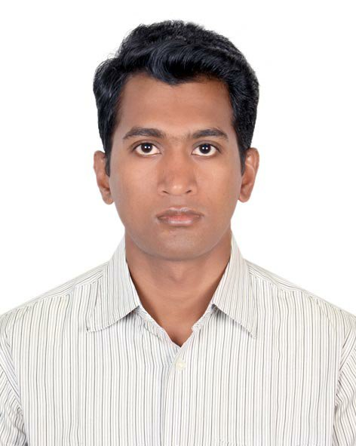

**MD. SALAHUDDIN RANA**

270/4, North Kafrul, Dhaka-Cantonment, Dhaka-1206

# Mobile No: 01558853010, Email: ranaamire88@gmail.com

**JOB OBJECTIVE:** To secure a challenging position employing my strong educational background with working experience to utilize my passion, leadership, managing power & communication skills which will make me successful one of a winning team.

**ACADEMIC PROFILES:**

|  |  |  |  |  |
| --- | --- | --- | --- | --- |
| **Name of Degree or certificate** | **Concentration** | **Institution** | **Result: Division/ CGPA** | **Year of Passing** |
| **Masters of Business Administration** (MBA) | Finance & Banking | Govt Titumir College, Dhaka  Under Dhaka University | Appeared | |
| **Bachelor of Business Administration** (BBA) | Finance & Banking | Tejgaon College, Dhaka  Under National University | 2.80 out of 4.00 | 2015 |
| **Higher Secondary School Certificate** (H.S.C.) | Business Studies | JessoreCantonment College, Jessore | 4.10 out of 5.00 | 2008 |
| **Secondary School Certificate** (S.S.C.) | Business Studies | B A F Shaheen School & College, Jessore | 4.56 out of 5.00 | 2006 |

**WORKING EXPERIENCE:**

Name of Organization : **Neer Shaba Sangstha**

Position : Administrative Officer

Period : From 01/07/2017 to now

Company Location : Bharab house, 101/h,west sultangoan, Rayer bazaar beribadh.

**Duties/Responsibilities:**

* Manages all correspondence within and outside the organization.
* Records all incoming and out-going letters and documents.
* Receives advice from the project Manager and Executive Director on relevant issues and tend to the information/inquiries sought.
* Conveys all the required instructions and policies of the organization to the staff and the views of the regional staff to the leading body.
* Monitors administrative aspects of the regional office/staff and evaluates discipline and punctuality of the staff to the assigned tasks.
* Ensure the maintenance of attendance register in office and also confirm staff attendance level in the field.
* Responsible to supervise the work, related to purchase of furniture, office equipment, computers, vehicles/motorbikes/bicycles, air conditioner and miscellaneous.
* Responsible to negotiate services agreements with vendors.
* Looks after administrative affairs of the Office.

**Previous Experience:**

1.Name of Organization : **bKash Ltd.**

Position : Officer (Call center)

Period : From 02/09/2016 to 01/06/2017

Company Location : 5, Paragoantower, mohakali CA,Dhaka.

**Duties/Responsibilities:**

* Obtains client information by answering telephone, talking with callers to find out their need; verifying information.
* Informs clients by explaining procedures; answering questions; providing information.
* Maintains and improves call quality by adhering to standards and guidelines; recommending improved procedures.
* Updates job knowledge by studying new product and participating in training opportunities.
* Handel incoming press inquires and coordinates responses with appropriate team members.
* Also any other duties instructed by the management from time to time.

2. Name of Organization : **United Hospital Ltd. Bangladesh**

Position : Officer (Customer Relationship Department)

Period : From 01/01/2016 to 30/07/2016

Company location : Plot-15, Road 71, Gulshan 2, Dhaka-1212

**PROFESSIONAL STRENGTHS:**

Good communication skills, both written & verbal.

Good at managing time and workload.

Leadership ability in teamwork.

Quick learning ability, strong analytical ability

Have interest to know new system and technology.

Have knowledge about health safety and environment & sports.

**SELF-MOTIVATION:**

Honest, punctual & sincere to work.

Self-motivated, ambitious, target oriented and confident.

Able to work under pressure, individually or in a team.

**COMPUTER SKILLS:**

Excellent computer literacy in basic and business application such as:

**Operating System :** Windows 98, Windows XP, Windows7

**MS Office :** MS Word, MS Excel, Power Point

**Bangla Type** : Bijoy Bayanno Classic

**Internet :** Application as well.

**LANGUAGE PROFECIENCY:**

Having a good command in writing and oral both Bengali and English.

**PERSONAL INFORMATION:**

Father’s Name : Md. Amirul Islam

Mother’s Name : Safily Islam

Permanent Address : Holding-570, Ponchogoli,Power house para, Arabpur, Jesssore

Present Address : 340/A, North Kafrul, Dhaka Cantonment, Dhaka-1206

Date OF Birth : 07th September, 1991

Nationality : Bangladeshi (by birth)

Status : Single

Height & Weight : 5’9’’ / 61 Kg

Blood Group : B+ve

Contact no : 01558853010

**HOBBIES:**

Traveling different places, playing games and watching movies and news.

**REFERANCES:**

|  |  |
| --- | --- |
| **Abdul Jabbar**  Department of Head Finance and banking  Govt Titumir College, Dhaka  Under National University Mobile:01822003571 | **Jashim Uddin**  Deputy Manager  Asin Town Development Ltd.  Mobile:01833311229 |

**Declaration:**

Hereby, I am declaring that all the information furnished above is true, complete & correct.

Sincerely yours,

C:\Users\shehab\Desktop\SALAHUDDIN RANA SIGNATURE.jpg

………………………………

**MD. SALAHUDDIN RANA**